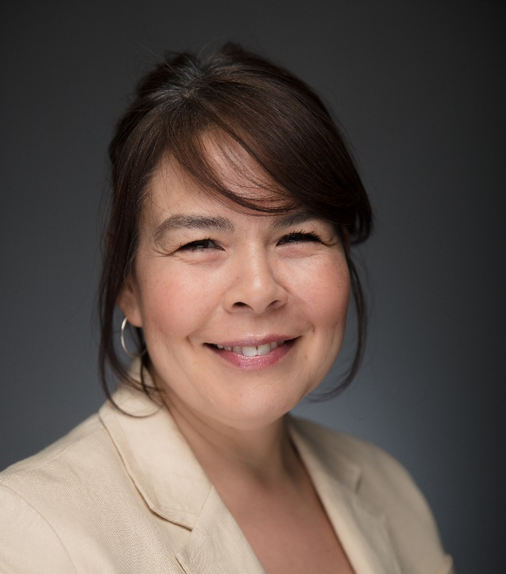
Community Partner Profile: Kimberly Fairman, Executive Director for the Institute for Circumpolar Health Research
Kimberly Fairman is a trained nurse from Inuvik and holds a Masters Degree in Public Health from the University of Alberta. She is the Executive Director for the Institute for Circumpolar Health Research, which pursues independent research related to health and wellness in circumpolar regions. Below, Kimberly shares some of her knowledge about the strengths, opportunities, and challenges for housing and homelessness in Yellowknife and the North broadly.
Can you talk about your organization and the work that you do?
The institute is an independent research organization located in Yellowknife in the Northwest Territories. We have a number of community partners throughout the territory but also across the circumpolar North. What we find through health systems research and particularly working with Indigenous peoples is that people living in arctic regions and people living in rural and remote communities experience health through a very similar lens across the circumpolar world, and that is through what we know as the social impacts of colonization that create different health outcomes for people living in the North.
The objective of the institute is to conduct and facilitate research at a community level that will improve the health outcomes of individuals living in these areas. Housing is one of the key social determinants of health. When we think about health outcomes, we can almost always expect housing to be one of the factors that impacts people’s experiences of health and wellness, particularly in the North and for Indigenous communities.
What are some of the challenges for housing and homelessness in Yellowknife?
There isn’t enough housing, and I also think that housing issues tend to be hidden to a certain extent because of the way that people misunderstand Indigenous culture and family units. I don’t know why that is, but people tend to think it’s normal to have 10 people living in a 3-bedroom house, or in some cases more than that. Another issue that I think is not talked about a lot but creates a lot of heath issues is the conditions of homes in the North. This is a complex issue because there is a lot of stigma associated with the condition of homes and around cleanliness and your ability to maintain a certain standard of living, so it is difficult to talk about. I also think the system has a really hard time responding to these issues because of some of the limitations of living in the North. For example, access to building materials and the length of time to plan out capital projects. In some ways this has facilitated a culture of unresponsiveness in terms of addressing housing needs for rural communities.
Another part of the problem is that housing is linked to employment, and so if you choose to work in a sector that doesn’t have housing as a benefit you often cannot live in your home community. There is a big gap in terms of what some people describe as a brain drain or people choosing not to live in and contribute to their home community because there are no feasible options to do so. From my own perspective, I am Nunavummiut, and I cannot live in my home community. There is an important self-determination piece to this, and it becomes a cyclical problem.
And what about some of the strengths and opportunities in Yellowknife?
There are a lot of community members with very strong cultural and language backgrounds who are thinking about housing in a lot of really creative ways, and also connecting it to self-determination. I think that the more activism there is around housing the more we will be able to leverage that for support through government channels. There has been some real recognition from the government that this is an investment that has a lot of implications for a lot of other social and health elements. There seems to be a bit more collaboration happening at an inter- and intra-departmental level in government.
As a community, Yellowknife has a lot of offer and some of these homeless projects are giving us an opportunity to understand better how we can care for community members and how we can spend a bit more time looking at how we want to take care of those members. With the COVID-19 pandemic we had to respond very quickly to some serious housing issues, and that pressure to do so helped us to see some creative solutions that maybe we had previously thought were less possible.
Are there any projects or initiatives happening in Yellowknife that excite you?
We have a lot of non-profit organizations that are doing amazing things for housing. One example is the Yellowknife Women’s Society who have created transitional housing units from an old motel, and I think with some of the research we have planned we will be able to highlight the positive impacts that that has for some of Yellowknife’s marginalized populations. We have an on-the-land healing camp that is exciting. It is an urban based camp, and they provide a breakfast service and access to traditional healing and counselling. They have managed to create a sense of community for individuals who didn’t have that before.
During the pandemic there were a lot of community discussions around the issue of homelessness and the day shelter and, to me, the fact that we were having those conversations at a community level was very positive. The more opportunities we have to have honest conversations about the issues, like homelessness and substance use, the deeper our understanding will be about the shame and guilt we feel as a community around these issues that prevents us from making progress.
What would you like to see from the AHIN partnership?
The AHIN partnership offers an opportunity to connect with a broader network of people working in this area. Sometimes at a community level we have capacity challenges, and this partnership has opened a door in terms of seeing what is happening in other parts of the country and understanding the strategic relationships that have allowed things to happen in other parts of the country. We have a small project that we will be doing here within the next year that is focused on the benefits of transitional housing and so we are already starting to see things happening.

